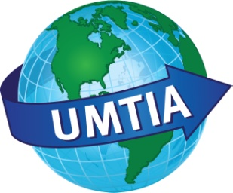

**UMTIA Upper Midwest Translators and Interpreters Association - Chapter of the American Translators Association**

**Location**:

Hennepin County Medical Center

730 S. 8th Street

RL 110: Red Building

Lower Level, Room 110

**Directions**:

<http://www.hcmc.org/general/directions.htm>

**Parking**:

<http://www.hcmc.org/general/parking.htm>

**It often takes months or years of interpreting across different specialties of medicine to learn, translate and classify medical terminology into a personal, comprehensive glossary. This workshop is designed to help you to begin compiling one such glossary for the specialty of Obstetrics, Gynecology and Genetic Counseling. Presented by a medical interpreter to fellow interpreters, its intent is not to elaborate on the science behind each medical term but to define, organize and translate the terminology we have learned through our experience as medical interpreters.**

**After a presentation of the basic concepts and most commonly used terms in OB/GYN and Genetic Counseling, each participant will receive a copy of the terminology. The participants will then work on translating the terminology in their language groups. The last hour will be reserved for general comments about the solutions for the difficult terms as well as a group discussion about how to prevent our personal beliefs and experiences from affecting the delivery of interpretation and the final health care outcome for the patient.**

**Saturday, April 14th, 2012**

**3 units of ATA**

**Continued Education Credit**

Registration:

8:00 a.m. to 8:45 a.m.

Presentation and questions:

9:00 a.m. to 12:00 p.m.

To register go to www.umtia.org

**UMTIA members $10.00**

**Non-members $20.00**

**On site $20.00**

 For more information contact the UMTIA Medical Interpreting Committee at: [medical@umtia.org](mailto:medical@umtia.org)

Compiling a Medical Interpreter's Glossary: Obstetrics, Gynecology and Genetic Counseling, by Elma Johnson