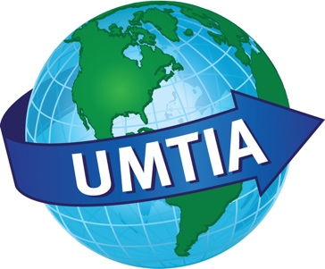

UMTIA
Upper Midwest Translators and Interpreters Association
Chapter of the American Translators Association

September 30th, 2017

Per the decision made at the UMTIA Board meeting on August 10th, 2017, the following is UMTIA’s current policy on credits and reimbursements.

Credit and Refund Policy: UMTIA will refund or credit a workshop fee when the participant contacts the treasurer requesting it before the event for which the fee was paid. The refund can be either a check sent to the participant, minus the Paypal costs that have been incurred, or a credit to participants account. The credit will be available until the end of the following calendar year, at which point the funds, if they have not been used by the participant to pay their membership fee or a workshop fee, will be incorporated into UMTIA's general funds in order to further the mission of the Association.

Signed:
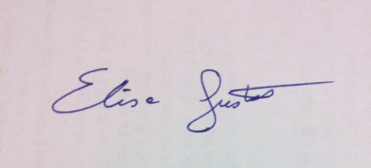

Elisa Gustafson

UMTIA President 2016-2017

